
PERTON PARISH COUNCIL

CIVILITY AND RESPECT POLICY

Introduction

1.1 Perton Parish Council believes that civility and respect are important in the working environment, and expect all councillors, officers and users of Parish Council facilities to be polite and courteous when working for, and with, the council.

1.2 Perton Parish Council is committed to creating a working environment where all council employees, councillors, contractors and others who come into contact with us in the course of our work, are treated with dignity, respect and courtesy. We aim to create a workplace where there is zero tolerance for harassment and bullying

1.3 In support of this objective, Perton Parish Council has signed up to the Civility Pledge, as a commitment to civility and respect in our work, and politeness and courtesy in behaviour, speech, and in the written word. Further information about the Civility and Respect Pledge is available NALC & SLCC

1.4 We recognise that there is a continuum where unaddressed issues have the potential to escalate and become larger, more complex issues and this policy sets out how concerns will be managed, however the emphasis of this policy is on resolution and mediation where appropriate, rather than an adversarial process.

1.5 This document:
- explains how we will respond to complaints of bullying or harassment;
- ensures that we respond sensitively and promptly; and,
- supports our employees in ensuring their behaviour does not amount to bullying and/or harassment by giving examples.

Scope

2.1 This policy covers bullying and harassment of and by, councillors, officers, staff and users Parish Council facilities a complaint connected to the Council be received this should be raised with the appropriate person

2.2 Agency staff, or contractors are equally expected to treat council colleagues, and other representatives, and stakeholders and users of Parish Council facilities with dignity and respect, and the council may terminate the contract, without notice, where there are suspicions of harassment or bullying.

2.3 Complaints about other employment matters will be managed under the council’s grievance policy.

2.4 It is noted that the management of a situation may differ depending on who the allegations relate to (e.g. employees, contractor, Councillor, or user of Parish Council facilities), however, the council will take appropriate action if any of its employees are bullied or harassed by employees, councillors, members of the public, suppliers or contractors.

General welfare

Perton Parish Council is also committed to fostering a caring and supportive environment for all. This commitment extends to promoting health, safety and general welfare to users of Parish Council facilities or services. A culture of civility and respect is fundamental to the wellbeing and safety of ALL individuals.
- Respectful Conduct: All interactions—verbal, written, and non-verbal—must be respectful and professional. Harassment, discrimination, intimidation, bullying, or abusive behaviour will not be tolerated.
- Inclusive Environment: Individuals shall be treated fairly regardless of race, colour, religion, gender, sexual orientation, gender identity or expression, age, disability, nationality, or any other protected characteristic.
- Constructive Communication: Disagreements are to be addressed thoughtfully and constructively, focusing on ideas and behaviours rather than personal attacks.
- Shared Responsibility: Every member shares responsibility for maintaining a culture that supports emotional, psychological, and physical well-being.
- Accountability: Behaviour that undermines the general welfare or violates standards of civility and respect may result in steps to address the issue
By upholding these principles, the council seeks to ensure a healthy, respectful environment that supports individual well-being and collective success.

Bullying

4.1 All council representatives and users of facilities or services are entitled to dignity, respect and courtesy and to not experience any form of discrimination. Perton Parish Council will not tolerate bullying or harassment in the workplace or at work-related events outside of the workplace, whether the conduct is a one-off act or repeated course of conduct, and whether harm is intended or not. Neither will they tolerate retaliation against, or victimisation of, any person involved in bringing a complaint of harassment or bullying. You should also be aware that, if you have bullied or harassed someone (e.g. physical violence, harassment), in some circumstances the treatment may amount to a crime punishable by a fine or imprisonment.

4.2 We expect all representatives of the council and users of facilities or services to treat each other with respect and uphold the values of the code of conduct, civility and respect pledge, equality & Diversity policy, and all other policies and procedures set by the Council where appropriate.

4.3 We expect you to demonstrate respect by listening and paying attention to others, having consideration for other people’s feelings, following protocols and rules, showing appreciation and thanks, and being kind.

4.4 Allegations of bullying and harassment will be treated seriously. Investigations will be carried out promptly, sensitively and, as far as possible, confidentially. See the grievance policy for further details regarding the process. Employees and others who make allegations of bullying or harassment in good faith will not be treated less favourably as a result.

4.5 False accusations of harassment or bullying can have a serious effect on innocent individuals. Staff and others have a responsibility not to make false allegations. While we will assume that all complaints of bullying and harassment are made in good faith, in the event that allegations are found to be malicious or vexatious the person raising the complaint may be subject to action under the council’s disciplinary procedure.
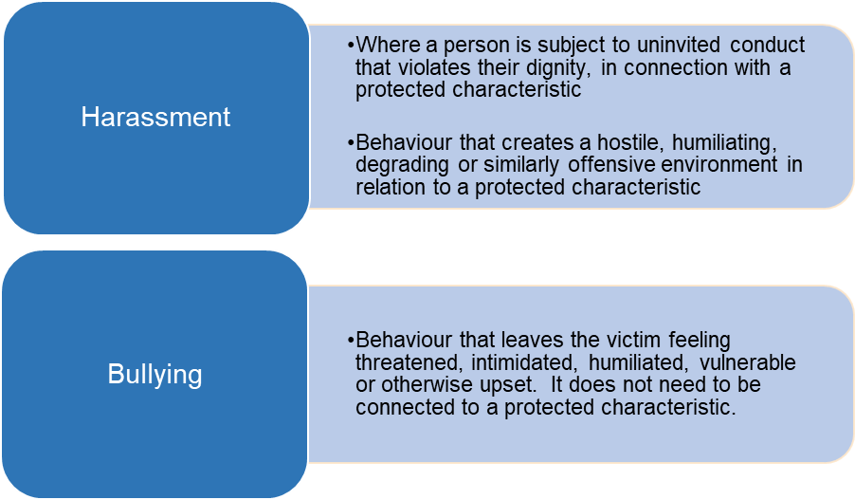

Type of treatment that amounts to bullying or harassment

‘Bullying’ or ‘harassment’ are phrases that apply to treatment from one person (or a group of people) to another that is unwanted and that has the effect of violating that person’s dignity or creating an intimidating, hostile, degrading, humiliating, or offensive environment for that person.

5.2 Examples of bullying and harassment include:
- Physical conduct ranging from unwelcome touching to serious assault
- Unwelcome sexual advances
- The offer of rewards for going along with sexual advances e.g. promotion, access to training
- Threats for rejecting sexual advances
- Demeaning comments about a person’s appearance
- Verbal abuse or offensive comments, including jokes or pranks related to age, disability, gender re-assignment, marriage, civil partnership, pregnancy, maternity, race, religion, belief, sex or sexual orientation
- Unwanted nicknames, especially related to a person's age, disability, gender re-assignment, marriage, civil partnership, pregnancy, maternity, race, religion, belief, sex or sexual orientation
- Spreading malicious rumours or insulting someone
- Lewd or suggestive comments or gestures
- Deliberate exclusion from conversations, work activities or social activities.
- Withholding information a person needs in order to do their job
- Practical jokes, initiation ceremonies or inappropriate birthday rituals
- Physical abuse such as hitting, pushing or jostling
- Rifling through, hiding or damaging personal property
- Display of pictures or objects with sexual or racial overtones, even if not directed at any particular person
- Isolation or non-cooperation at work
- Subjecting a person to humiliation or ridicule, belittling their efforts, whether directly and / or in front of others
- The use of obscene gestures
- Abusing a position of power

5.3 Bullying and harassment can occur through verbal and face to face interactions but can also take place through sharing inappropriate or offensive content in writing or via email and other electronic communications and social media.

It is important to recognise that conduct which one person may find acceptable, another may find totally unacceptable and behaviour could be harassment when the person had no intention to offend. We all have the right to determine what offends us. Some behaviour will be clear to any reasonable person that it is likely to offend – for example sexual touching. Other examples may be less clear; however, you should be aware that harassment will occur if behaviour continues after the recipient has advised you that the behaviour is unacceptable to them.

Harassment can also occur where the unwanted behaviour relates to a perceived characteristic (such as offensive jokes or comments based on the assumption someone is gay, even if they are not) or due to their association with someone else (such as harassment related to their partner having a disability for example). See the council’s equality and diversity Policy.

5.6 All employees must, therefore, treat their colleagues and users of facilities or services with respect and appropriate sensitivity and should feel able to challenge behaviour that they find offensive even if it is not directed at them.
It is important to recognise that bullying does not include appropriate criticism of an employee’s behaviour or effective, robust performance management. Constructive and fair feedback about your behaviour or performance from your manager or colleagues/Councillors is not bullying. It is part of normal employment and management routines and should not be interpreted as anything different.

Victimisation

6.1 Victimisation is subjecting a person to a detriment because they have, in good faith, complained (whether formally or otherwise) that someone has been bullying or harassing them or someone else, or supported someone to make a complaint or given evidence in relation to a complaint. This would include isolating someone because they have made a complaint or giving them a heavier or more difficult workload.

6.2 Provided that you act in good faith, i.e. you genuinely believe that what you are saying is true, you have a right not to be victimised for making a complaint or doing anything in relation to a complaint of bullying or harassment and the council will take appropriate action to deal with any alleged victimisation, which may include disciplinary action against anyone found to have victimised you.

6.3 Making a complaint that you know to be untrue, or giving evidence that you know to be untrue, may lead to disciplinary action being taken against you.

Reporting concerns

7.1 What you should do if you feel you are being bullied or harassed by a member of the public or supplier (as opposed to a colleague)

7.2 If you are being bullied or harassed by someone with whom you come into contact at work, please raise this with your nominated manager in the first instance or, with the clerk/or a councillor. Any such report will be taken seriously, and we will decide how best to deal with the situation, in consultation with you.

7.3 What you should do if you feel you are being bullied or harassed by a councillor:

If you are being bullied or harassed by a councillor, please raise this with the Clerk or the Chairman of the Council in the first instance. They will then decide how best to deal with the situation, in consultation with you. Formal concerns regarding potential breaches of the Councillors Code of Conduct must be investigated by the Monitoring Officer.

7.4 The council will consider reasonable measures to protect employee health and safety. Such measures may include a temporary change in duties or change of work location, not attending meetings with the person about whom the complaint has been made etc.

7.5 What you should do if you witness an incident you believe to harassment or bullying: If you witness such behaviour, you should report the incident in confidence to the clerk/ officer or a councillor. Such reports will be taken seriously and will be treated in strict confidence as far as it is possible to do so.

7.6 What you should do if you are being bullied or harassed by another member of staff or contractor, see Grievance and Disciplinary Policies for further information.

Review of Policy

8.1 This policy to be reviewed at the beginning of each four year term, or earlier if there are material or legislation changes.

Adopted: February 2023
Reviewed/Revised: March 2026
Next review : February 2030
Committee: Full Council

