Clerks’ Report
Week ending 13th March 2026
Email distribution
SCC – nighttime economy survey
SCC Food waste information

Other matters
4 street lights not working at the subway to Edgehill Drive, reported to Staffordshire County Council
Followed up with Staffordshire Highways the possibility of changing the road layout at the junction of Pattingham Road and Jenny Walkers Lane.
I can confirm that WPR/ Pattingham Road/ Jenny Walkers Lane signalised crossroads is being reviewed as part of the live planning applications we have for Perton Phase 2 (25/00839/OUTM) and Land at Heath House Lane, Codsall (25/00874/OUTM).
Our development control team are reviewing the traffic flows and potential signals design, and further information will be available in due course.
South Staffordshire District Council – installation of street lighting at Richmond Drive junction with Playing fields:
We do not currently have plans to install lighting along this stretch, as we only consider installations where issues have been raised by the police.
Given that no concerns have been identified, and due to budget constraints, we will not be taking this forward at this time. If the area begins to experience ASB or other issues in the future, we may revisit the need for lighting.
Staffordshire Highways – reported flooding on A41 Ref: DRN005583

Severn Drive Speed Indicator Device - Unfortunately, there is an issue with this device. The date was displaying as 1970. Although it was reset previously, it has reverted back to 1970 again. Will remove it and test at the centre.

Wrottesley Park Road Speed Indicator Device
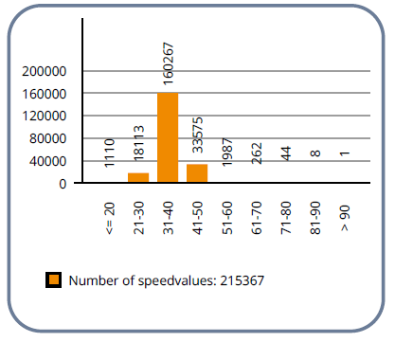
10th February – 13th March 2026


