Clerks’ Report
Week ending 10th April 2026
Email distribution
Digital democracy trial
Community Foundation Newsletter April
NALC Chief Execs bulletin
CPRE Staffordshire Spring 2026 Newsletter

Other matters
Devolution – link to Q & A information.
SCC requested information on the project funded through the Community Fund. The bus shelter refurbishment will be used as a case study in their annual report.
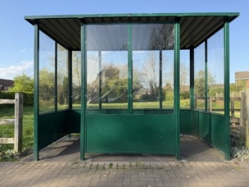

SSDC have repaired the bridge in the woodland at the playing fields.
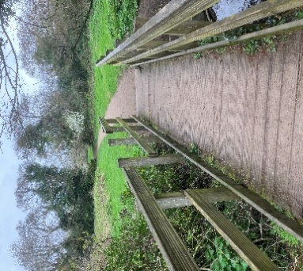

A resident reported a House of Multiple Occupancy (HMO). District Councillors confirm that the District Council were monitoring the situation.

