Clerks’ Report
Week ending 3rd July 2026
Email distribution

Other matters
British Gas - two new non-energy costs (a new levy and a significant increase in network costs)
From 3rd August 206 a levy and an additional network cost will be added to the monthly bill. This is as a result of government policy. Ofgem notified this change in July 2025.
- April 2026, the cost of using the electricity network increased significantly to support further investment in the electricity network.
- December 2025, a new levy was introduced to help fund future low-carbon electricity generation.
The contracted standing charge and unit rate stay the same. The increase will be £14.72 per month.

Outdoor Gym equipment mechanisms have all been greased.
Broken toilet seat in the ladies has been replaced.

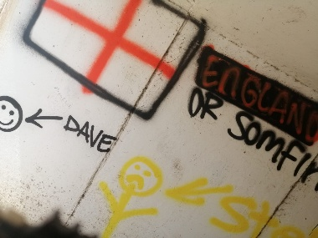


Graffiti reported in the subway at the lower lake. SSDC have been and covered anything offensive.

