Clerks’ Report
Week ending 24th July 2026
Email distribution

Other matters
A complaint regarding the play area surface has been received. The Caretakers will try and repair the small section that is missing but the weather make this difficult. The compound will not set with the heat. The gate has also been removed – the fixings top and bottom have been bent and was hanging off.
It has been reported that two wheelbarrows have been removed from plots at Perton Jubilee Allotments, an email has gone out to all plot holders to advise that they must not enter another plot or ‘borrow’ anything without permission from the plot holder. We have asked for more information and for the wheelbarrows to be returned.
South Staffordshire Local plan consultation submission completed.

Wrottesley Park Road 19th June – 17th July 2026
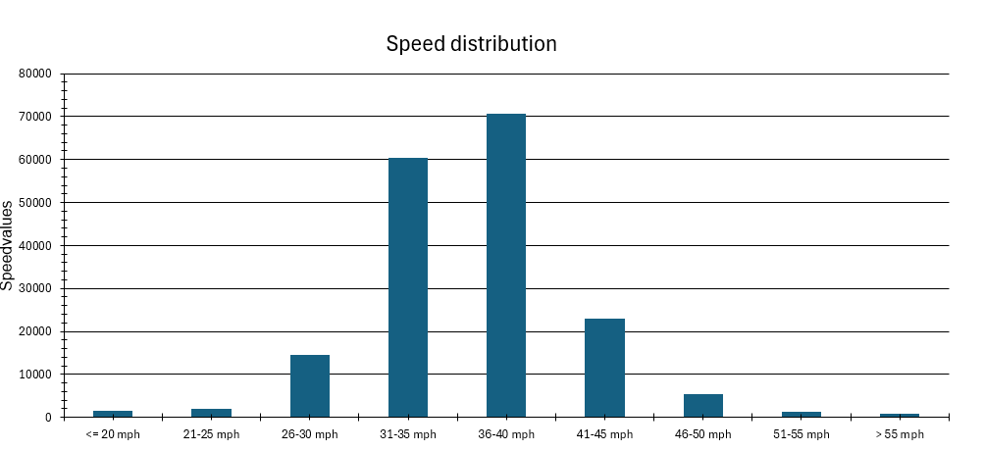
16.99% vehicles over the speed limit of 40mph
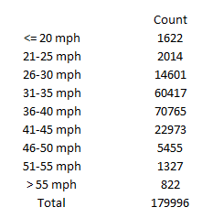

The missing MUGA panel has been replaced and the junior multiplay equipment has been repaired.
A reported dislodged manhole cover in Elgin Court reported to SSDC. Replaced the same day.
Letter sent to Mike Wood MP regarding the Planning and Infrastructure Act 2025 and the proposed provision which may significantly reduce or remove the ability of elected members to ‘call in’ planning applications for determination by a planning committee.

