Clerks’ Report
Week ending 14th August 2026
Email distribution
MP letter of support for the planning concerns MP planning.pdf

Other matters

Chairman’s report
3rd August Corsers Court – I would just like to say a huge thank you to Sue for attending today it was very much appreciated.
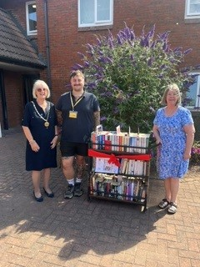
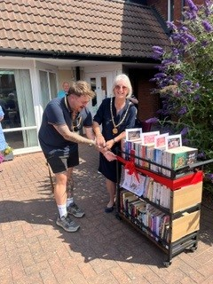

9th August Parkrun - I attended on Sunday together with Judith and other Councillors’
to the 1st birthday of the junior park run and it was also the 50th park run for them. They expressed their thanks to the parish council for all their help and support without which this wouldn't have gotten this far.
They also wish to pass on their thanks for the caretakers clearing the adult run in the wood as this was extremely good.

External Audit provision – Perton Parish Council has registered under the SAAA Phased Rollout of Digital AGAR Portal

