Environmental Report 179/20
Great Perton Spring Clean: Keep Britain Tidy have now officially launched the Great British Spring Clean from 28 May to 13 June 2021.

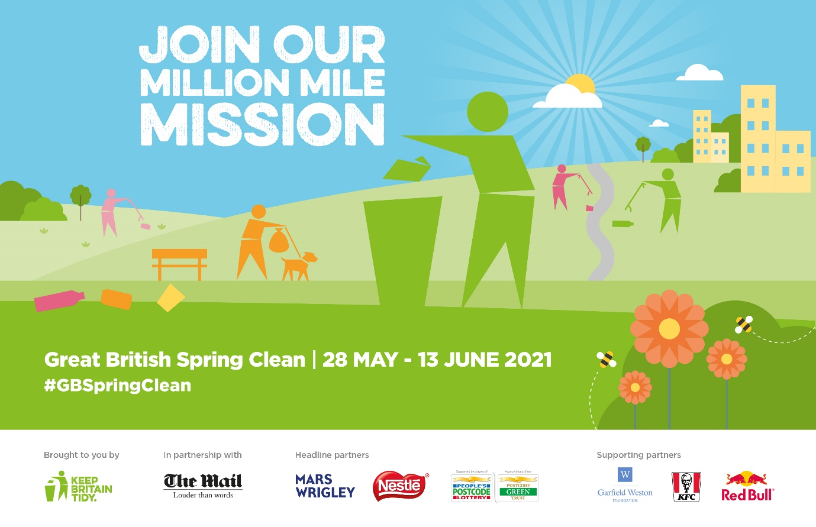

This includes a call to individuals and groups to pledge their time to litter pick during the period of the Spring Clean. It is important that people who litter pick do so lawfully under the COVID-19 guidance pertaining at the time. Currently some 50,591 individuals have pledged their support.
​
Wild About Perton will pay for additional litter pickers. It is suggested that Perton Parish Council put out a call to local people to support the Great Perton Spring Clean and pledge their time and pledge where they will undertake their spring clean, for example near where they live, or a local public open space working individually or in small groups.

Open Space Improvement Scheme: There was mention made at the Locality 4 Forum on Wednesday 23rd March which I attended of an Open Spaces Improvement Scheme. After the meeting I asked the District for further information and how as a Parish, Perton might engage with the scheme. Andrew Aston responded to explain that he was taking the lead and that he was interested in ideas from Parishes that could be taken forward. A particular open space might be showcased to show what could be achieved if partners worked together. There was also the potential to install an interpretation board afterwards to show what had been done and the partners involved.

One site in Perton might be a suitable candidate i.e. the meadow next to the Lower Lake, a gateway site for Perton, where Street Scene and Wild About Perton volunteer Cynthia Tilley have worked together to improve the meadow for biodiversity. More needs to be done including improving the nearby seating area and managing erosion of the bankside.

Archaeology in Mind: Voluntary archaeology group Archaeology in Mind excavated two of the buildings associated with RAF Perton in Bluebell Walk during 2019 & 2020. Unfortunately work to complete the excavation, including mapping the remains, updating the interpretation boards and preparing for an exhibition in Perton Library was interrupted by COVID-19.

During the lockdown Friends of Perton Library asked Archaeology in Mind to prepare a public presentation of their work to date. The presentation is now complete and will be premiered on Wednesday 12th May at 7PM using the Zoom platform. Registration is free through Eventbrite. Full details with be available soon through Perton Library.

Keith Elder
Parish Councillor, Lakeside Ward
7th April 2021

