2nd June 2021
MEMBERS OF THE FINANCE COMMITTEE
Dear Sir/Madam,
You are summoned to the meeting of the Finance Committee to be held in the Boardroom, Perton Civic Centre on Tuesday 8th June 2021 at 10.00am.
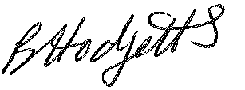
Becky Hodgetts
Clerk to the Council

AGENDA

F01/21 - To receive apologies for Absence

F02/21 - To receive Declaration of Disclosable Pecuniary and Other Interests from the Agenda

F03/21 - To approve requests for Code of Conduct Dispensations

F04/21 - To approve minutes of the Finance meeting held on 4th May 2021

F05/21 - To approve List of payments for May 2021

F06/21 - To review income received for May 2021

F07/21 - To review budget to date & approve Virements

F08/21 - To approve reconciliations for Bank accounts and petty cash

F09/21 - To approve date and time of next meeting: 6th July 2021 at 10.00am

