29th June 2021
MEMBERS OF THE FINANCE COMMITTEE
Dear Sir/Madam,
You are summoned to the meeting of the Finance Committee to be held in the Boardroom, Perton Civic Centre on Tuesday 6th July 2021 at 10.00am.
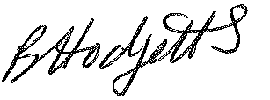
Becky Hodgetts
Clerk to the Council

AGENDA

F10/21 - To receive apologies for Absence

F11/21 - To receive Declaration of Disclosable Pecuniary and Other Interests from the Agenda

F12/21 - To approve requests for Code of Conduct Dispensations

F13/21 - To approve minutes of the Finance meeting held on 8th June 2021

F14/21 - To approve List of payments for June 2021

F15/21 - To review income received for June 2021

F16/21 - To review budget to date & approve Virements

F17/21 - To approve reconciliations for Bank accounts and petty cash

F18/21 - To approve date and time of next meeting: 7th September 2021 at 10.00am

