24th June 2025

Dear Councillors .
You are summoned to the meeting of Perton Parish Council Allotment Oversight Committee, to be held in the board room, Perton Civic Centre on Thursday 3rd July 2025 at 7.00pm.
Yours faithfully
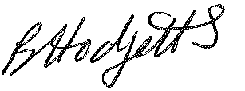
Becky Hodgetts
Clerk to the Council

All persons attending this meeting are hereby notified that this meeting will be recorded by the Parish Council to assist the Parish Clerk in the compilation of minutes. The recording will be deleted once the minutes have been approved.

AGENDA

A01/25 To receive apologies for absence

A02/25 To receive Declaration of Disclosable Pecuniary and Other Interests from the Agenda

A03/25 To discuss and agree the future management of the allotments

A04/25 Date and time of next meeting – 2nd October 2025 at 7.00pm

