17th June 2025
Dear Councillor
You are summoned to the Extra Ordinary Meeting of Perton Parish Council, to be held in the Board room, Perton Civic Centre on Monday, 23rd June 2025 at 7.00pm.

Yours faithfully
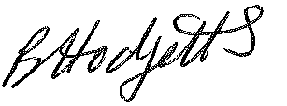
Mrs B Hodgetts
Clerk to the Council

All persons attending this meeting are hereby notified that this meeting will be recorded by the Parish Council to assist the Parish Clerk in the compilation of minutes. The recording will be deleted once the minutes have been approved.

AGENDA

30/25 To note apologies for Absence

31/25 To receive presentation from Land Fund in relation to safeguarded land adjacent to Wrottesley Village

32/25 - Date and time of next meeting – Perton Civic Centre, Board room 7pm
Full Council Meeting of Perton Parish Council – 14th July 2025

Crime & Disorder Implications
Section 17 of the Crime & Disorder Act 1998, places a duty on a local authority to consider crime and disorder implications and to exercise its various functions with due regard to the likely effect of the exercise of those functions and to do all that it reasonably can to prevent crime and disorder in its area. Where relevant any decisions made at the Parish Council meeting have taken this duty of care into consideration.

