25th June 2024

Dear Councillors .
You are summoned to the meeting of Perton Parish Council Allotment Committee, to be held in the board room, Perton Civic Centre on Wednesday 3rd July 2024 at 5.00pm. Committee members are also invited to attend
Yours faithfully
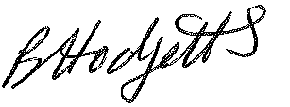
Becky Hodgetts
Clerk to the Council

All persons attending this meeting are hereby notified that this meeting will be recorded by the Parish Council to assist the Parish Clerk in the compilation of minutes. The recording will be deleted once the minutes have been approved.

AGENDA

A10/24 To receive apologies for absence

A11/24 To receive Declaration of Disclosable Pecuniary and Other Interests from the Agenda

A12/24 Minutes - To approve minutes of the Allotment Committee meeting held on 29th May 2024
A13/24 Allotment report

A14/24 Site : To discuss the following

management of the site: suggestions from committee and tenants
- Swaps table
- Gap in hedge from water connection
- Best Kept Plot competition
- Additional gate in the fence
- Social day
- BVQ – change disposable rule in rule book
- Ground by plot 32 – build up under fence
- Purchase of petrol strimmer/brush cutter

A15/24 Items for next agenda - to propose items for future agendas

A16/24 Date and time of next meeting - To agree the next meeting date

