25th March 2022

Dear Councillor
You are summoned to the extra meeting of Perton Parish Council, to be held in the Board Room, Perton Civic Centre on Thursday, 31st March 2022 at 7.00pm.
Yours faithfully
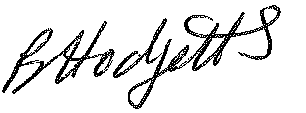
Mrs Becky Hodgetts,
Clerk to the Council

All persons attending this meeting are hereby notified that this meeting will be recorded by the Parish Council to assist the Parish Clerk in the compilation of minutes. The recording will be deleted once the minutes have been approved.

AGENDA

172/21 - Public Open Session
Time for this session is limited to 30 minutes as per Standing Order number 3F. Members of the Public are invited to address the Parish Council (limited to 3 minutes per person as per Standing Order number 3G).

173/21 – Apologies - To receive and note apologies for absence

174/21 – To review Asset Register

175/21 – To review Risk Management record

Crime & Disorder Implications
Section 17 of the Crime & Disorder Act 1998, places a duty on a local authority to consider crime and disorder implications and to exercise its various functions with due regard to the likely effect of the exercise of those functions and to do all that it reasonably can to prevent crime and disorder in its area. Where relevant any decisions made at the Parish Council meeting have taken this duty of care into consideration

