24th February 2023

Dear Councillor
You are summoned to the Extra Ordinary Meeting of Perton Parish Council, to be held in the Board room, Perton Civic Centre on Monday, 6th March 2023 at 7.00pm.
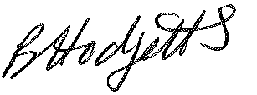
Yours faithfully

Mrs Becky Hodgetts,
Clerk to the Council

All persons attending this meeting are hereby notified that this meeting will be recorded by the Parish Council to assist the Parish Clerk in the compilation of minutes. The recording will be deleted once the minutes have been approved.

AGENDA

151/22 - Public Open Session
Time for this session is limited to 30 minutes as per Standing Order number 3F. Members of the Public are invited to address the Parish Council (limited to 3 minutes per person as per Standing Order number 3G)

152/22 -To receive apologies for absence

153/22 - Declaration of Disclosable Pecuniary Interest
To receive Declarations of Disclosable Pecuniary and Other Interests from the Agenda

154/22 - To discuss use of the Civic Centre on Saturday mornings for The Chill Out Club including hire charges.

155/22 - Date and time of next meeting – Perton Civic Centre, Board room 7pm
Full Council – Monday 13th March 2023

