25th June 2024

Dear Councillors .
You are summoned to the meeting of Perton Parish Council Allotment Committee, to be held in the board room, Perton Civic Centre on Wednesday 4th September 2024 at 6.00pm. Committee members are also invited to attend
Yours faithfully
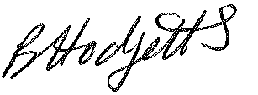
Becky Hodgetts
Clerk to the Council

All persons attending this meeting are hereby notified that this meeting will be recorded by the Parish Council to assist the Parish Clerk in the compilation of minutes. The recording will be deleted once the minutes have been approved.

AGENDA

A25/24 To receive apologies for absence

A26/24 To receive Declaration of Disclosable Pecuniary and Other Interests from the Agenda

A19/24 Minutes - To approve minutes of the Allotment Committee meeting held on 3rd July 2024
A20/24 Allotment report

A21/24 Site : To discuss the following

management of the site: suggestions from committee and tenants
- new plot allocation- update
- Swaps table - update
- Gap in hedge from water connection - update
- Best Kept Plot competition - update
- Social day – update
- Additional gate in the fence - update
- BBQ – change disposable rule in rule book
- New water trough

A22/24 Presentation - to receive an update

A23/24 Items for next agenda - to propose items for future agendas

A24/24 Date and time of next meeting - To agree the next meeting date

