20th August 2024
Dear Councillor
You are summoned to an Extra Ordinary Meeting of Perton Parish Council, to be held in the Board room, Perton Civic Centre on Tuesday, 27th August 2024 at 7.00pm.
Yours faithfully
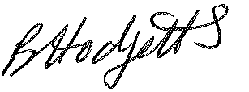
Mrs Becky Hodgetts,
Clerk to the Council

All persons attending this meeting are hereby notified that this meeting will be recorded to assist the Parish Clerk in the compilation of minutes. The recording will be deleted once the minutes have been approved.
AGENDA

67/24 - Public Open Session
Members of the Public are invited to address the Parish Council (limited to 3 minutes per person as per Standing Order number 3G) Time for this session is limited to 30 minutes as per Standing Order number 3F.

68/24 Apologies for Absence – to note apologies received from Councillors

69/23 Code of Conduct – Dispensation
To approve requests for Code of Conduct Dispensations. (A request for a dispensation must be made in writing to the Clerk and be granted by decision of the Council)

70/23 Local Councils Award Scheme
To confirm that the required criteria are in place before submission.

71/24 Date and time of next meeting – Perton Civic Centre, Board room 7pm
Full Council Meeting of Perton Parish Council – 9th September 2024

