21st March 2025

Dear Councillors .
You are summoned to the meeting of Perton Parish Council Allotment Committee, to be held in the board room, Perton Civic Centre on Wednesday 26th March 2025 at 6.00pm. Committee members are also invited to attend
Yours faithfully
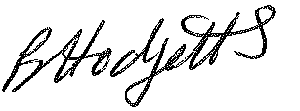
Becky Hodgetts
Clerk to the Council

All persons attending this meeting are hereby notified that this meeting will be recorded by the Parish Council to assist the Parish Clerk in the compilation of minutes. The recording will be deleted once the minutes have been approved.

AGENDA

A54/24 To receive apologies for absence

A55/24 To receive Declaration of Disclosable Pecuniary and Other Interests from the Agenda

A56/24 Minutes - To approve minutes of the Allotment Committee meeting held on 20th November 2024

A57/24 Site: To discuss the following
- To consider plot holders additional fence request
- To consider the draft constitutions and agree preferred option
- To consider a speaker on Climate Change Gardening.

A58/24 Best Kept Village - to consider decorating/refurbishing a bus shelter

A59/24 to consider supporting the Live Healthy – Live Happy event Monday 6th June

A60/24 Items for next agenda - to propose items for future agendas

A61/24 Date and time of next meeting – 24th September 2025

