24th June 2025
MEMBERS OF THE PLANNING COMMITTEE
Dear Sir/Madam,
You are summoned to the meeting of the Planning Committee to be held in the Boardroom, Perton Civic Centre on Tuesday 1st July 2025 at 7pm.
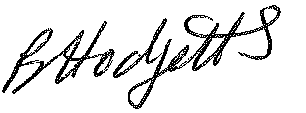
Becky Hodgetts
Clerk to the Council

AGENDA

P01/25 - To receive apologies for Absence

P02/25 - To receive Declaration of Disclosable Pecuniary and Other Interests from the Agenda

P03/25 - To receive and approve requests for Code of Conduct Dispensations

P04/25 - To approve the minutes of the planning meeting held on 1st December 2022

P05/25 - To note planning applications returned since last meeting

P06/25 - To note planning applications approved since last meeting

P07/25 - To receive and consider the application listed below

Application No: 25/00357/FUL

Proposed: detached replacement dwelling

Location: Hunterswood, Pattingham Road, Perton, WV6 7HD

Application No: 25/00270/COUM

Proposed: use of land as cemetery (burial ground) and provision of car park and access drives

Location: South Perton Farm, Jenny Walkers Lane, Perton, WV6 7HB

P08/25 - To agree date and time of next meeting

