25th June 2024
MEMBERS OF THE FINANCE COMMITTEE
Dear Sir/Madam,
You are summoned to the meeting of the Finance Committee to be held in the Boardroom, Perton Civic Centre on Tuesday 2nd July 2024 at 10.00am.
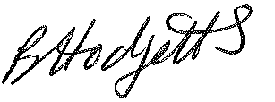
Becky Hodgetts
Clerk to the Council
All persons attending this meeting are hereby notified that this meeting will be recorded by the Parish Council to assist the Parish Clerk in the compilation of minutes. The recording will be deleted once the minutes have been approved.

AGENDA

F12/24 - To receive apologies for Absence

F13/24 - To receive Declaration of Disclosable Pecuniary and Other Interests from the Agenda

F14/24 - To approve requests for Code of Conduct Dispensations

F15/24 - To approve minutes of the Finance meeting held on 4th June 2024

F16/24 - To approve List of payments for June 2024

F17/24 - To review income received for June 2024

F18/24- To review and approve the Grant Policy with suggested amendments
F19/24 – To review the current variable Direct Debit instructions as per Financial Regulation 7.5

F20/24 - To review budget to date & approve Virements

F21/24 - To approve reconciliations for bank accounts and petty cash

F22/24 - Date and time of next meeting: Tuesday 3rd September 2024 at 10.00am

