27th October 2021
MEMBERS OF THE FINANCE COMMITTEE
Dear Sir/Madam,
You are summoned to the meeting of the Finance Committee to be held in the Boardroom, Perton Civic Centre on Tuesday 2nd November 2021 at 10.00am.
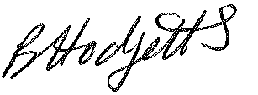
Becky Hodgetts
Clerk to the Council

AGENDA

F38/21 - To receive apologies for Absence

F39/21 - To receive Declaration of Disclosable Pecuniary and Other Interests from the Agenda

F40/21 - To approve requests for Code of Conduct Dispensations

F41/21 - To approve minutes of the Finance meeting held on 5th October 2021

F42/21 - To approve List of payments for October 2021

F43/21 - To review income received for October 2021

F44/21 - To review budget to date & approve Virements

F45/21 - To approve reconciliations for bank accounts and petty cash

F46/21 - To approve date and time of next meeting: Tuesday 7th December 2021 at 10.00am
Thursday 6th January 2022 at 10.00am

