28th May 2025
MEMBERS OF THE FINANCE COMMITTEE
Dear Sir/Madam,
You are summoned to the meeting of the Finance Committee to be held in the Boardroom, Perton Civic Centre on Tuesday 3rd June 2025 at 10.00am.
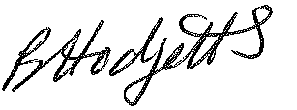
Becky Hodgetts
Clerk to the Council
All persons attending this meeting are hereby notified that this meeting will be recorded by the Parish Council to assist the Parish Clerk in the compilation of minutes. The recording will be deleted once the minutes have been approved.

AGENDA

F10/25 - To receive apologies for Absence

F11/25 - To receive Declaration of Disclosable Pecuniary and Other Interests from the Agenda

F12/25 - To approve requests for Code of Conduct Dispensations

F13/25 - To approve minutes of the Finance meeting held on 6th May 2025

F14/25 - To approve List of payments for May 2025

F15/25 - To review income received for May 2025

F16/25 - To review budget to date & approve Virements

F17/25 - To approve reconciliations for bank accounts and petty cash

F18/25 - Date and time of next meeting: Tuesday 8th July 2025 at 10.00am

