29th August 2024
MEMBERS OF THE FINANCE COMMITTEE
Dear Sir/Madam,
You are summoned to the meeting of the Finance Committee to be held in the Boardroom, Perton Civic Centre on Tuesday 3rd September 2024 at 10.00am.
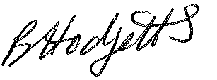
Becky Hodgetts
Clerk to the Council
All persons attending this meeting are hereby notified that this meeting will be recorded by the Parish Council to assist the Parish Clerk in the compilation of minutes. The recording will be deleted once the minutes have been approved.

AGENDA

F23/24 - To receive apologies for Absence

F24/24 - To receive Declaration of Disclosable Pecuniary and Other Interests from the Agenda

F25/24 - To approve requests for Code of Conduct Dispensations

F26/24 - To approve minutes of the Finance meeting held on 2nd July 2024

F27/24 - To approve List of payments for July & August 2024

F28/24 - To review income received for July & August 2024

F29/24 - To review budget to date & approve Virements

F30/24 - To approve reconciliations for bank accounts and petty cash

F31/24 - Date and time of next meeting: Tuesday 8th October 2024 at 10.00am

