28th November 2024
MEMBERS OF THE FINANCE COMMITTEE
Dear Sir/Madam,
You are summoned to the meeting of the Finance Committee to be held in the Boardroom, Perton Civic Centre on Tuesday 3rd December 2024 at 10.00am.
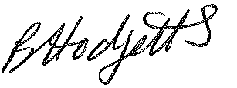
Becky Hodgetts
Clerk to the Council
All persons attending this meeting are hereby notified that this meeting will be recorded by the Parish Council to assist the Parish Clerk in the compilation of minutes. The recording will be deleted once the minutes have been approved.

AGENDA

F50/24 - To receive apologies for Absence

F51/24 - To receive Declaration of Disclosable Pecuniary and Other Interests from the Agenda

F52/24 - To approve requests for Code of Conduct Dispensations

F53/24 - To approve minutes of the Finance meeting held on Tuesday 5th November 2024

F54/24 - To approve List of payments for November 2024

F55/24 - To review income received for November 2024

F56/24 - To review budget to date & approve Virements

F57/24 - To approve reconciliations for bank accounts and petty cash

F58/24 - Date and time of next meeting: Tuesday 7th January 2025 at 10.00am

