22nd December 2023
MEMBERS OF THE FINANCE COMMITTEE
Dear Sir/Madam,
You are summoned to the meeting of the Finance Committee to be held in the Boardroom, Perton Civic Centre on Thursday 4th January 2024 at 10.00am.
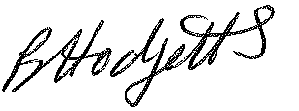
Becky Hodgetts
Clerk to the Council
All persons attending this meeting are hereby notified that this meeting will be recorded by the Parish Council to assist the Parish Clerk in the compilation of minutes. The recording will be deleted once the minutes have been approved.

AGENDA

F57/23 - To receive apologies for Absence

F58/23 - To receive Declaration of Disclosable Pecuniary and Other Interests from the Agenda

F59/23 - To approve requests for Code of Conduct Dispensations

F60/23 - To approve minutes of the Finance meeting held on 5th December 2023

F61/23 - To approve List of payments for December 2023

F62/23 - To review income received for December 2023

F63/23 - To review budget to date & approve Virements

F64/23 - To approve reconciliations for bank accounts and petty cash

F65/23 - Date and time of next meeting: Tuesday 6th February 2024 at 10.00am

