25th February 2025
MEMBERS OF THE FINANCE COMMITTEE
Dear Sir/Madam,
You are summoned to the meeting of the Finance Committee to be held in the Boardroom, Perton Civic Centre on Tuesday 4th March 2025 at 10.00am.
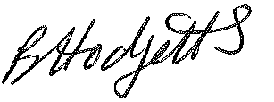
Becky Hodgetts
Clerk to the Council
All persons attending this meeting are hereby notified that this meeting will be recorded by the Parish Council to assist the Parish Clerk in the compilation of minutes. The recording will be deleted once the minutes have been approved.

AGENDA

F77/24 - To receive apologies for Absence

F78/24 - To receive Declaration of Disclosable Pecuniary and Other Interests from the Agenda

F79/24 - To approve requests for Code of Conduct Dispensations

F80/24 - To approve minutes of the Finance meeting held on Tuesday 4th February 2025

F81/24 - To approve List of payments for February 2025

F82/24 - To review income received for February 2025

F83/24 - To review budget to date & approve Virements

F84/24 - To approve reconciliations for bank accounts and petty cash

F85/24 - Date and time of next meeting: Tuesday 8th April 2025 at 10.00am

