25th March 2024
MEMBERS OF THE FINANCE COMMITTEE
Dear Sir/Madam,
You are summoned to the meeting of the Finance Committee to be held in the Boardroom, Perton Civic Centre on Thursday 4th April 2024 at 10.00am.
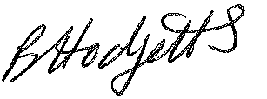
Becky Hodgetts
Clerk to the Council
All persons attending this meeting are hereby notified that this meeting will be recorded by the Parish Council to assist the Parish Clerk in the compilation of minutes. The recording will be deleted once the minutes have been approved.

AGENDA

F84/23 - To receive apologies for Absence

F85/23 - To receive Declaration of Disclosable Pecuniary and Other Interests from the Agenda

F86/23 - To approve requests for Code of Conduct Dispensations

F87/23 - To approve minutes of the Finance meeting held on 5th March 2024

F88/23 - To approve List of payments for March 2024

F89/23 - To review income received for March 2024

F90/23 - To review budget to date & approve Virements

F91/23 - To approve reconciliations for bank accounts and petty cash

F92/23 - Date and time of next meeting: Tuesday 7th May 2024 at 10.00am

