27th June 2023
MEMBERS OF THE FINANCE COMMITTEE
Dear Sir/Madam,
You are summoned to the meeting of the Finance Committee to be held in the Boardroom, Perton Civic Centre on Tuesday 4th July 2023 at 10.00am.
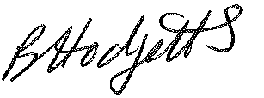
Louise Higgins
Assistant Clerk to the Council
All persons attending this meeting are hereby notified that this meeting will be recorded by the Parish Council to assist the Parish Clerk in the compilation of minutes. The recording will be deleted once the minutes have been approved.

AGENDA

F11/23 - To receive apologies for Absence

F12/23 - To receive Declaration of Disclosable Pecuniary and Other Interests from the Agenda

F13/23 - To approve requests for Code of Conduct Dispensations

F14/23 - To approve minutes of the Finance meeting held on 6th June 2023

F15/23 - To approve List of payments for June 2023

F16/23 - To review income received for June 2023

F17/23 - To review budget to date & approve Virements

F18/23 - To approve reconciliations for bank accounts and petty cash

F19/23 - Date and time of next meeting: Tuesday 5th September 2023 at 10.00am

