29th February 2024
MEMBERS OF THE FINANCE COMMITTEE
Dear Sir/Madam,
You are summoned to the meeting of the Finance Committee to be held in the Boardroom, Perton Civic Centre on Tuesday 5th March 2024 at 10.00am.
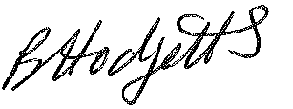
Becky Hodgetts
Clerk to the Council
All persons attending this meeting are hereby notified that this meeting will be recorded by the Parish Council to assist the Parish Clerk in the compilation of minutes. The recording will be deleted once the minutes have been approved.

AGENDA

F75/23 - To receive apologies for Absence

F76/23 - To receive Declaration of Disclosable Pecuniary and Other Interests from the Agenda

F77/23 - To approve requests for Code of Conduct Dispensations

F78/23 - To approve minutes of the Finance meeting held on 6th February 2024

F79/23 - To approve List of payments for February 2024

F80/23 - To review income received for February 2024

F81/23 - To review budget to date & approve Virements

F82/23 - To approve reconciliations for bank accounts and petty cash

F83/23 - Date and time of next meeting: Thursday 4th April 2024 at 10.00am

