29th October 2024
MEMBERS OF THE FINANCE COMMITTEE
Dear Sir/Madam,
You are summoned to the meeting of the Finance Committee to be held in the Boardroom, Perton Civic Centre on Tuesday 5th November 2024 at 10.00am.
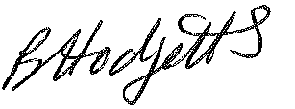
Becky Hodgetts
Clerk to the Council
All persons attending this meeting are hereby notified that this meeting will be recorded by the Parish Council to assist the Parish Clerk in the compilation of minutes. The recording will be deleted once the minutes have been approved.

AGENDA

F41/24 - To receive apologies for Absence

F42/24 - To receive Declaration of Disclosable Pecuniary and Other Interests from the Agenda

F43/24 - To approve requests for Code of Conduct Dispensations

F44/24 - To approve minutes of the Finance meeting held on Tuesday 8th October 2024

F45/24 - To approve List of payments for October 2024

F46/24 - To review income received for October 2024

F47/24 - To review budget to date & approve Virements

F48/24 - To approve reconciliations for bank accounts and petty cash

F49/24 - Date and time of next meeting: Tuesday 2nd December 2024 at 10.00am

