27th November 2023
MEMBERS OF THE FINANCE COMMITTEE
Dear Sir/Madam,
You are summoned to the meeting of the Finance Committee to be held in the Boardroom, Perton Civic Centre on Tuesday 5th December 2023 at 10.00am.
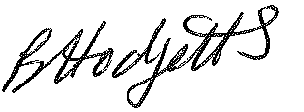
Becky Hodgetts
Clerk to the Council
All persons attending this meeting are hereby notified that this meeting will be recorded by the Parish Council to assist the Parish Clerk in the compilation of minutes. The recording will be deleted once the minutes have been approved.

AGENDA

F48/23 - To receive apologies for Absence

F49/23 - To receive Declaration of Disclosable Pecuniary and Other Interests from the Agenda

F50/23 - To approve requests for Code of Conduct Dispensations

F51/23 - To approve minutes of the Finance meeting held on 7thNovember 2023

F52/23 - To approve List of payments for November 2023

F53/23 - To review income received for November 2023

F54/23 - To review budget to date & approve Virements

F55/23 - To approve reconciliations for bank accounts and petty cash

F56/23 - Date and time of next meeting: Tuesday 4th January 2024 at 10.00am

