30th January 2024
MEMBERS OF THE FINANCE COMMITTEE
Dear Sir/Madam,
You are summoned to the meeting of the Finance Committee to be held in the Boardroom, Perton Civic Centre on Tuesday 6th February 2024 at 10.00am.
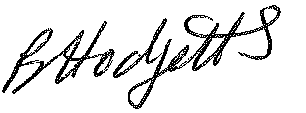
Becky Hodgetts
Clerk to the Council
All persons attending this meeting are hereby notified that this meeting will be recorded by the Parish Council to assist the Parish Clerk in the compilation of minutes. The recording will be deleted once the minutes have been approved.

AGENDA

F66/23 - To receive apologies for Absence

F67/23 - To receive Declaration of Disclosable Pecuniary and Other Interests from the Agenda

F68/23 - To approve requests for Code of Conduct Dispensations

F69/23 - To approve minutes of the Finance meeting held on 4th January 2024

F70/23 - To approve List of payments for January 2024

F71/23 - To review income received for January 2024

F72/23 - To review budget to date & approve Virements

F73/23 - To approve reconciliations for bank accounts and petty cash

F74/23 - Date and time of next meeting: Tuesday 5th March 2024 at 10.00am

