23rd May 2023
MEMBERS OF THE FINANCE COMMITTEE
Dear Sir/Madam,
You are summoned to the meeting of the Finance Committee to be held in the Boardroom, Perton Civic Centre on Tuesday 6th June 2023 at 10.00am.
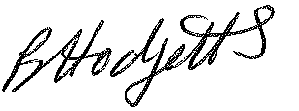
Becky Hodgetts
Clerk to the Council
All persons attending this meeting are hereby notified that this meeting will be recorded by the Parish Council to assist the Parish Clerk in the compilation of minutes. The recording will be deleted once the minutes have been approved.

AGENDA

F01/23 - To receive apologies for Absence

F02/23 - To receive Declaration of Disclosable Pecuniary and Other Interests from the Agenda

F03/23 - To approve requests for Code of Conduct Dispensations

F04/23 - To approve minutes of the Finance meeting held on 11th April 2023

F05/23 - To approve List of payments for May 2023

F06/23 - To review income received for May 2023

F07/23 - To review budget to date & approve Virements

F08/23 - To consider revised budget

F09/23 - To approve reconciliations for bank accounts and petty cash

F10/23 - Date and time of next meeting: Tuesday 4th July 2023 at 10.00am

