1st October 2026
MEMBERS OF THE FINANCE COMMITTEE
Dear Sir/Madam,
You are summoned to the meeting of the Finance Committee to be held in the Boardroom, Perton Civic Centre on Tuesday 6th October 2026 at 10.00am.
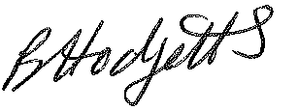
Becky Hodgetts
Clerk to the Council
All persons attending this meeting are hereby notified that this meeting will be recorded by the Parish Council to assist the Parish Clerk in the compilation of minutes. The recording will be deleted once the minutes have been approved.

AGENDA

F31/26 - To receive apologies for Absence

F32/26 - To receive Declaration of Disclosable Pecuniary and Other Interests from the Agenda

F33/26 - To approve requests for Code of Conduct Dispensations

F34/26 - To approve minutes of the Finance meeting held on 8th September 2026

F35/26 - To approve List of payments for September 2026

F36/26 - To review income received for September 2026

F37/26 - To review budget to date & approve Virements

F38/26 - To approve reconciliations for bank accounts

F39/26 - Date and time of next meeting: Tuesday 3rd November 2025 at 10.00am

