30th November 2022
MEMBERS OF THE FINANCE COMMITTEE
Dear Sir/Madam,
You are summoned to the meeting of the Finance Committee to be held in the Boardroom, Perton Civic Centre on Tuesday 6th December 2022 at 10.00am.
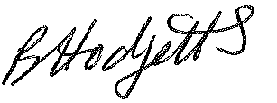
Becky Hodgetts
Clerk to the Council
All persons attending this meeting are hereby notified that this meeting will be recorded by the Parish Council to assist the Parish Clerk in the compilation of minutes. The recording will be deleted once the minutes have been approved.

AGENDA

F47/22 - To receive apologies for Absence

F48/22 - To receive Declaration of Disclosable Pecuniary and Other Interests from the Agenda

F49/22 - To approve requests for Code of Conduct Dispensations

F50/22 - To approve minutes of the Finance meeting held on 8th November 2022

F51/22 - To approve List of payments for November 2022

F52/22 - To review income received for November 2022

F53/22 - To review budget to date & approve Virements

F54/22 - To approve reconciliations for bank accounts and petty cash

F55/22 - Date and time of next meeting: Thursday 5th January 2023 at 10.00am

