4th January 2022
MEMBERS OF THE FINANCE COMMITTEE
Dear Sir/Madam,
You are summoned to the meeting of the Finance Committee to be held in the Boardroom, Perton Civic Centre on Thursday 6th January 2022 at 10.00am.
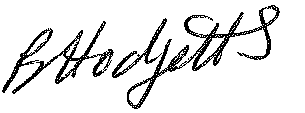
Becky Hodgetts
Clerk to the Council

AGENDA

F56/21 - To receive apologies for Absence

F57/21 - To receive Declaration of Disclosable Pecuniary and Other Interests from the Agenda

F58/21 - To approve requests for Code of Conduct Dispensations

F59/21 - To approve minutes of the Finance meeting held on 7th December 2021

F60/21 - To approve List of payments for December 2021

F61/21 - To review income received for December 2021

F62/21 - To review budget to date & approve Virements

F63/21 - To approve reconciliations for bank accounts and petty cash

F64/21 - Date and time of next meeting: Tuesday 8th February 2022 at 10.00am

