23rd December 2024
MEMBERS OF THE FINANCE COMMITTEE
Dear Sir/Madam,
You are summoned to the meeting of the Finance Committee to be held in the Boardroom, Perton Civic Centre on Tuesday 7th January 2025 at 10.00am.
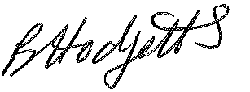
Becky Hodgetts
Clerk to the Council
All persons attending this meeting are hereby notified that this meeting will be recorded by the Parish Council to assist the Parish Clerk in the compilation of minutes. The recording will be deleted once the minutes have been approved.

AGENDA

F59/24 - To receive apologies for Absence

F60/24 - To receive Declaration of Disclosable Pecuniary and Other Interests from the Agenda

F61/24 - To approve requests for Code of Conduct Dispensations

F62/24 - To approve minutes of the Finance meeting held on Tuesday 3rd December 2024

F63/24 - To approve List of payments for December 2024

F64/24 - To review income received for December 2024

F65/24 - To review budget to date & approve Virements

F66/24 - To approve reconciliations for bank accounts and petty cash

F67/24 - Date and time of next meeting: Tuesday 4th February 2025 at 10.00am

