2nd February 2023
MEMBERS OF THE FINANCE COMMITTEE
Dear Sir/Madam,
You are summoned to the meeting of the Finance Committee to be held in the Boardroom, Perton Civic Centre on Tuesday 7th February at 10.00am.
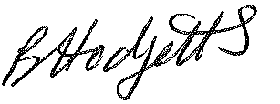
Becky Hodgetts
Clerk to the Council
All persons attending this meeting are hereby notified that this meeting will be recorded by the Parish Council to assist the Parish Clerk in the compilation of minutes. The recording will be deleted once the minutes have been approved.

AGENDA

F65/22 - To receive apologies for Absence

F66/22 - To receive Declaration of Disclosable Pecuniary and Other Interests from the Agenda

F67/22 - To approve requests for Code of Conduct Dispensations

F68/22 - To approve minutes of the Finance meeting held 5th January 2023

F69/22 - To approve List of payments for January 2023

F70/22 - To review income received for January 2023

F71/22 - To review budget to date & approve Virements

F72/22 - To approve reconciliations for bank accounts and petty cash

F73/22 - Date and time of next meeting: Tuesday 7th March 2023 at 10.00am

