30th April 2024
MEMBERS OF THE FINANCE COMMITTEE
Dear Sir/Madam,
You are summoned to the meeting of the Finance Committee to be held in the Boardroom, Perton Civic Centre on Tuesday 7th May 2024 at 10.00am.
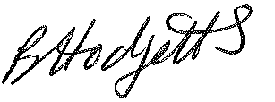
Becky Hodgetts
Clerk to the Council
All persons attending this meeting are hereby notified that this meeting will be recorded by the Parish Council to assist the Parish Clerk in the compilation of minutes. The recording will be deleted once the minutes have been approved.

AGENDA

F93/23 - To receive apologies for Absence

F94/23 - To receive Declaration of Disclosable Pecuniary and Other Interests from the Agenda

F95/23 - To approve requests for Code of Conduct Dispensations

F96/23 - To approve minutes of the Finance meeting held on 4th April 2024

F97/23 - To approve List of payments for April 2024

F98/23 - To review income received for April 2024

F99/23 - To review budget to date & approve Virements

F100/23 - To approve reconciliations for bank accounts and petty cash

F101/23 - Date and time of next meeting: Tuesday 4th June 2024 at 10.00am

