28th October 2023
MEMBERS OF THE FINANCE COMMITTEE
Dear Sir/Madam,
You are summoned to the meeting of the Finance Committee to be held in the Boardroom, Perton Civic Centre on Tuesday 7th November 2023 at 10.00am.
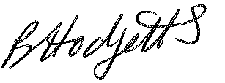
Becky Hodgetts
Clerk to the Council
All persons attending this meeting are hereby notified that this meeting will be recorded by the Parish Council to assist the Parish Clerk in the compilation of minutes. The recording will be deleted once the minutes have been approved.

AGENDA

F39/23 - To receive apologies for Absence

F40/23 - To receive Declaration of Disclosable Pecuniary and Other Interests from the Agenda

F41/23 - To approve requests for Code of Conduct Dispensations

F42/23 - To approve minutes of the Finance meeting held on 5th October 2023

F43/23 - To approve List of payments for October 2023

F44/23 - To review income received for October 2023

F45/23 - To review budget to date & approve Virements

F46/23 - To approve reconciliations for bank accounts and petty cash

F47/23 - Date and time of next meeting: Tuesday 5th December 2023 at 10.00am

