1st December 2021
MEMBERS OF THE FINANCE COMMITTEE
Dear Sir/Madam,
You are summoned to the meeting of the Finance Committee to be held in the Boardroom, Perton Civic Centre on Tuesday 7th December 2021 at 10.00am.
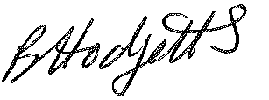
Becky Hodgetts
Clerk to the Council

AGENDA

F47/21 - To receive apologies for Absence

F48/21 - To receive Declaration of Disclosable Pecuniary and Other Interests from the Agenda

F49/21 - To approve requests for Code of Conduct Dispensations

F50/21 - To approve minutes of the Finance meeting held on 5th November 2021

F51/21 - To approve List of payments for November 2021

F52/21 - To review income received for November 2021

F53/21 - To review budget to date & approve Virements

F54/21 - To approve reconciliations for bank accounts and petty cash

F55/21 - Date and time of next meeting: Thursday 6th January 2022 at 10.00am

