3rd July 2025
MEMBERS OF THE FINANCE COMMITTEE
Dear Sir/Madam,
You are summoned to the meeting of the Finance Committee to be held in the Boardroom, Perton Civic Centre on Tuesday 8th July 2025 at 10.00am.
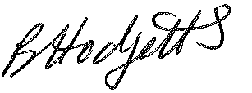
Becky Hodgetts
Clerk to the Council
All persons attending this meeting are hereby notified that this meeting will be recorded by the Parish Council to assist the Parish Clerk in the compilation of minutes. The recording will be deleted once the minutes have been approved.

AGENDA

F19/25 - To receive apologies for Absence

F20/25 - To receive Declaration of Disclosable Pecuniary and Other Interests from the Agenda

F21/25 - To approve requests for Code of Conduct Dispensations

F22/25 - To approve minutes of the Finance meeting held on 3rd June 2025

F23/25 – To review the following policies
- Investment strategy – no amendments
- Reserves Policy – no amendments
- Petty Cash Policy – revised to replace with Prepayment card.

F24/25 - To approve List of payments for June 2025

F25/25 - To review income received for June 2025

F26/25 - To review budget to date & approve Virements

F27/25 - To approve reconciliations for bank accounts and petty cash

F28/25 - Date and time of next meeting: Tuesday 2nd September 2025 at 10.00am

