2nd October 2024
MEMBERS OF THE FINANCE COMMITTEE
Dear Sir/Madam,
You are summoned to the meeting of the Finance Committee to be held in the Boardroom, Perton Civic Centre on Tuesday 8th October 2024 at 10.00am.
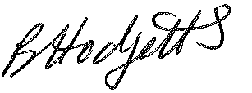
Becky Hodgetts
Clerk to the Council
All persons attending this meeting are hereby notified that this meeting will be recorded by the Parish Council to assist the Parish Clerk in the compilation of minutes. The recording will be deleted once the minutes have been approved.

AGENDA

F32/24 - To receive apologies for Absence

F33/24 - To receive Declaration of Disclosable Pecuniary and Other Interests from the Agenda

F34/24 - To approve requests for Code of Conduct Dispensations

F35/24 - To approve minutes of the Finance meeting held on

Tuesday 3rd September 2024
- Thursday 4th April 2024 –meeting held in May was not quorate, approval of minutes missed from subsequent meetings.

F36/24 - To approve List of payments for September 2024

F37/24 - To review income received for September 2024

F38/24 - To review budget to date & approve Virements

F39/24 - To approve reconciliations for bank accounts and petty cash

F40/24 - Date and time of next meeting: Tuesday 5th November 2024 at 10.00am

