1st November 2022
MEMBERS OF THE FINANCE COMMITTEE
Dear Sir/Madam,
You are summoned to the meeting of the Finance Committee to be held in the Boardroom, Perton Civic Centre on Tuesday 8th November 2022 at 10.00am.
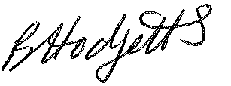
Becky Hodgetts
Clerk to the Council
All persons attending this meeting are hereby notified that this meeting will be recorded by the Parish Council to assist the Parish Clerk in the compilation of minutes. The recording will be deleted once the minutes have been approved.

AGENDA

F38/22 - To receive apologies for Absence

F39/22 - To receive Declaration of Disclosable Pecuniary and Other Interests from the Agenda

F40/22 - To approve requests for Code of Conduct Dispensations

F41/22 - To approve minutes of the Finance meeting held on 4th October 2022

F42/22 - To approve List of payments for October 2022

F43/22 - To review income received for October 2022

F44/22 - To review budget to date & approve Virements

F45/22 - To approve reconciliations for bank accounts and petty cash

F46/22 - Date and time of next meeting: Tuesday 6th December 2022 at 10.00am

