28th September 2021
MEMBERS OF THE FINANCE COMMITTEE
Dear Sir/Madam,
You are summoned to the meeting of the Finance Committee to be held in the Boardroom, Perton Civic Centre on Tuesday 5th October 2021 at 10.00am.
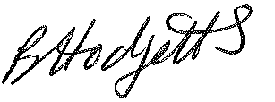
Becky Hodgetts
Clerk to the Council

AGENDA

F29/21 - To receive apologies for Absence

F30/21 - To receive Declaration of Disclosable Pecuniary and Other Interests from the Agenda

F31/21 - To approve requests for Code of Conduct Dispensations

F32/21 - To approve minutes of the Finance meeting held on 8th September 2021

F33/21 - To approve List of payments for September 2021

F34/21 - To review income received for September 2021

F35/21 - To review budget to date & approve Virements

F36/21 - To approve reconciliations for bank accounts and petty cash

F37/21 - To approve date and time of next meeting: 2nd November 2021 at 10.00am

