31st August 2021
MEMBERS OF THE FINANCE COMMITTEE
Dear Sir/Madam,
You are summoned to the meeting of the Finance Committee to be held in the Boardroom, Perton Civic Centre on Wednesday 8th September 2021 at 10.00am.
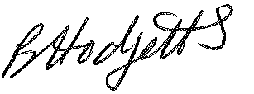
Becky Hodgetts
Clerk to the Council

AGENDA

F19/21 - To receive apologies for Absence

F20/21 - To receive Declaration of Disclosable Pecuniary and Other Interests from the Agenda

F21/21 - To approve requests for Code of Conduct Dispensations

F22/21 - To approve minutes of the Finance meeting held on 8th June 2021

F23/21 - To approve List of payments for July & August 2021

F24/21 - To review income received for July & August 2021

F25/21 - To review budget to date & approve Virements

F26/21 - To approve reconciliations for bank accounts and petty cash

F27/21 - To Review the following policies and approve any amendments
- Petty Cash
- Grant Policy
F28/21 - To approve reconciliations for bank accounts and petty cash

F29/21 - To approve date and time of next meeting: 5th October 2021 at 10.00am

