PARISH COUNCIL MEETINGS Public Open session from 7pm
Date of next meetings: Monday 11th November 2024
Monday 9th December 2024
‘FLICKS IN THE STICKS’ Movies at 2pm
11th December 2024 film to be advised
Email: clerk@pertonparishcouncil.gov.uk with any film suggestions
All welcome - £4.00 Perton Parish Senior Citizens – Free of charge
Future film dates: 19th February 2025
CIVIC CENTRE
Have you seen the range of events or classes at Perton Civic Centre? Take a look at our Facebook page or website for further information.

Should you wish to consider hiring the Civic Centre for your function please email bookings@pertonparishcouncil.gov.uk or telephone 01902 745971 (during office hours)

FIREWORKS
The Parish Council are once again holding a 10 minute firework display at Perton Middle School at 6pm on Sunday 3rd November 2024
There will be a collection for the Chairmans Charities – Compton Care and Kingswood Trust. Any spare change would be very welcome
A reminder that parking is limited and please bring a torch there is limited lighting on site.

SOUTH STAFFORDSHIRE COUNCIL
50th Anniversary Celebration
The winner of the Building Inclusion in the Community Award goes to Keith Elder.
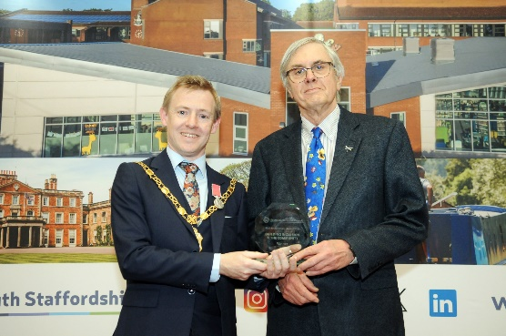
A long-time volunteer, Keith Elder has dedicated over 15 years to connecting people with environmental issues as Chair of Wild about Perton and continues to promote the value of volunteering through his work with Perton Parish Council, Support Staffordshire, and Friends of Perton Library.
Most notably, Keith has played a key role in establishing the "Men in Sheds" group, fostering social connections, practical work, and mental well-being for men in the community.
His commitment to inclusion and community well-being is truly inspiring.

Facebook page - https://www.facebook.com/pertonparishcouncil
For full details and contact information for your local Councillor please see the Parish Council website: https://www.pertonparishcouncil.gov.uk

