PARISH COUNCIL MEETINGS Public Open session from 7pm
Date of next meetings: Monday 14th October 2024
Monday 11th November 2024
‘FLICKS IN THE STICKS’ Movies at 2pm
11th December 2024 film to be advised
Email: clerk@pertonparishcouncil.gov.uk with any film suggestions
All welcome - £4.00 Perton Parish Senior Citizens – Free of charge
Future film dates: 19th February 2025
CIVIC CENTRE
Have you seen the range of events or classes at Perton Civic Centre?

Take a look at our Facebook page or website for further information.

Should you wish to consider hiring the Civic Centre for your function please email bookings@pertonparishcouncil.gov.uk or telephone 01902 745971 (during office hours)
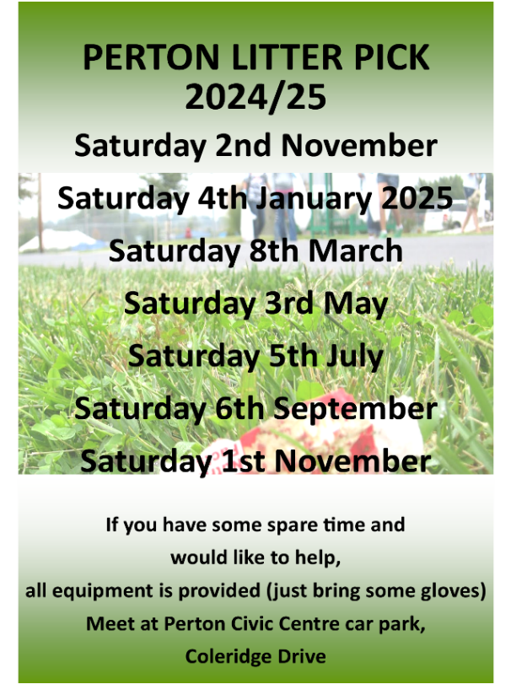 | 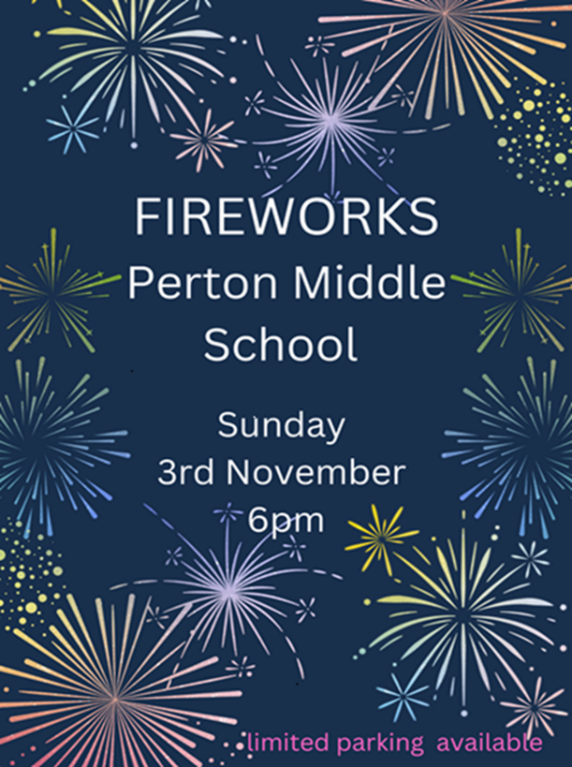

Facebook page - https://www.facebook.com/pertonparishcouncil
For full details and contact information for your local Councillor please see the Parish Council website: https://www.pertonparishcouncil.gov.uk

